A PROJECT REPORT

ON

“ TIMESHEET MANAGEMENT ”

Team Name : Time Titans

**Submitted to: Submitted by:**

**Alin Asha I**

**Ishwaryaseka J**

**Nishma N**

**Vidhya P**

**1.0 ABSTRACT**

The Time Titans project is an advanced web-based application crafted to streamline the management of employee time tracking and approval processes. This system is segmented into three main modules, each tailored to meet the needs of different roles within the organization: Employee, Lead, and Manager.

For the Employee module, users first access the system through a dedicated login page where they authenticate their credentials. Once logged in, they can use the Add/Update Timesheet Page to submit or update their working hours, including details such as start and end times, project information, and any relevant comments. This data is securely stored in the timesheet database. The View Timesheet Page allows employees to review their submitted timesheet entries in a tabular format, providing a clear view of their recorded hours and associated details. Additionally, a Logout Feature ensures that employees can exit the system securely, protecting their personal and work-related data.

The Lead module begins with a login page for leads to enter their credentials. Following authentication, leads can navigate to the Employee Detail Page, which provides a comprehensive overview of each employee's submitted timesheets. On the Timesheet Approval Page, leads have the ability to review and make decisions on each timesheet entry. They can approve or reject submissions, with these decisions being updated in the timesheet database to reflect the current status.

Similarly, the Manager module starts with a login page for managers to access their functionalities. Managers have access to the Employee Detail Page, which displays detailed information about each employee's timesheet submissions. The Timesheet Approval Page in this module allows managers to review and make final approval or rejection decisions on timesheet entries. These decisions are recorded in the database, ensuring that the status of each timesheet is accurately updated.

The Time Titans application is designed to enhance the efficiency, accuracy, and transparency of time management within the organization.

**Table Content**

1.0 Abstract …………………………………………………………………………………..1

2.0 Project Overview ………………………………………………………………………... 3

3.0 System Architecture …………………………………………………………………….. 3

4.0 Project Structure ………………………………………………………………………… 4

5.0 Database Structure ………………………………………………………......................... 5

6.0 Key Goals and Objective ………………………………………………………………... 6

7.0 Existing Feature ………………………………………………….....................................6

7.1 Employee Dashboard …………………………………………………………………7

7.1.1 Overview ………………………………………………………………………...7

7.1.2 Key Features and Fields …………………………………………………………8

7.2 Lead Dashboard ……………………………………………………………………..10

7.2.1 Overview ……………………………………………………………………….10

7.2.2 Key Features and Fields ………………………………………………………..10

7.3 Manager Dashboard ………………………………………………………………..12

7.3.1 Overview ……………………………………………………………………….13

7.3.2 Key Features and Fields ………………………………………………………..13

8.0 System Requirements ………………………………………………………………….16

8.1 Browser Requirement ……………………………………………………………...16

8.2 Backend Requirement ……………………………………………………………..16

8.3 Frontend Requirement ……………………………………………………………..17

8.4 Styling Requirement ……………………………………………………………….17

9.0 User Interface Requirement …………………………………………………………....19

9.1 General UI Requirement …………………………………………………………..19

9.2 Employee Dashboard UI …………………………………………………………..20

9.3 Lead Dashboard UI ………………………………………………………………..23

9.4 Manager Dashboard UI ……………………………………………………………27

9.5 HR Dashboard UI…………………………………………………………………..29

10.0 Implementation Plan …………………………………………………………………..30

11.0 Data Requirement ……………………………………………………………………..34

12.0 Use Case Diagram …………………………………………………………………….35

13.0 Future Enhancements ………………………………………………………………....36

13.1 Send Notifications to Employee …………………………………………………...36

13.2 User Interface Enhancement ……………………………………………………….37

13.3 Enhance Output Reporting ………………………………………………………....37

14.0 Project Workflow ……………………………………………………………………....38

15.0 Conclusion ……………………………………………………………………………...50

2.0 **Project Overview**

**Project Name:** Time Titans  
**App Name (Backend):** time_titans_app  
**App Name (Frontend):** time_titans_frontend

The Time Titans project is a sophisticated web-based solution aimed at optimizing and managing employee time tracking and approval processes. Designed to cater to the distinct needs of employees, leads, and managers, this application offers a structured approach to handling timesheets and approval workflows. By providing a clear and organized system for recording, reviewing, and approving time data, Time Titans enhances both transparency and efficiency in time management across the organization.

**3.0 System Architecture:**

The architecture of Time Titans is comprised of two core components: the backend and the frontend. The backend, named **time_titans,** is responsible for data management and business logic. It handles the storage, retrieval, and processing of time tracking data, ensuring that all interactions with the database are efficient and secure. The frontend, named **time_titans_frontend,** delivers a user-friendly interface that allows users to interact with the system. It provides intuitive navigation and visual elements for users to manage their timesheets and review data effectively.

**Architecture:**

**FRONTEND REACT JS**

**F**

**Employee Module**

* + Login
  + Profile
  + Add Timesheet
  + View Timesheet
  + Calendar

**Lead Module**

* + Login
  + Home Page
  + Task
  + Team
  + Employees

**Manager Module**

* Login Page
* Home Page
* Task
* Team
* Employees

**BACKEND (Djangorestframework)**

**Employee Detail**

* + api/register
  + api/login
  + api/employee-details
  + api/employee-details/update-approval

zxgfhjkl;kjhgfd

**Employee details**

* + ID
  + Emp name
  + Start time
  + End time
  + Comments
  + Date
  + Total hours worked
  + Lead approval
  + Manager approval

**User Table**

* + - ID
    - Username
    - Email
    - Password
    - Role

**4.0** **Project Structure**

│Time_Titans  
├── backend/  
│   ├── manage.py  
│   ├── time_titans_app/  
│   │   ├── __init__.py  
│   │   ├── admin.py  
│   │   ├── apps.py  
│   │   ├── models.py  
│   │   ├── serializers.py  
│   │   ├── urls.py  
│   │   └── views.py  
│   └── Time_Titans/  
│       ├── __init__.py  
│       ├── settings.py  
│       ├── urls.py  
│       └── wsgi.py  
│  
├── time_titans_frontend/  
│   ├── public/  
│   ├── src/  
│   │   ├── components/  
│   │   │   ├── Employee/  
│   │   │   ├── Lead/  
│   │   │   ├── Manager/  
│   │   ├── App.js  
│   │   ├── index.js  
│   │   ├── services/  
│   │    
│   └── package.json  
│  
├── requirements.txt  
└── README.md

**5.0 Database Structure:**

The Time Titans project employs a well-organized database schema with three primary tables:

* **Users Table:** This table stores essential user credentials and profile details, including username, email, employee ID, position, joining date, and both password and confirm password fields. It is integral for user authentication and profile management.
* **Employee Details Table:** This table captures detailed records of employee timesheets. It includes fields for employee ID, employee name, start and end times, project name, comments, date, total hours worked, lead approval status, and manager approval status. This data is crucial for tracking employee work hours and managing approvals.
* **Project Table:** This table maintains records related to various projects, including employee ID, employee name, project name, project module, date, and project status. It supports project-specific reporting and management.

**6.0 Key Goals and Objectives**

**1. Accurate Time Tracking**

The primary goal is to ensure that time tracking is accurate and reliable. This involves:

Automated Time Entries: Integrating features to automatically record hours

Worked based on system activities or manual entries.Error Reduction:

Implementing validation rules and user prompts to minimize entry errors and discrepancies.

Real-time Updates: Providing employees with instant feedback on their time

entries to correct any inaccuracies immediately.

**2. Project Management**

Progress Tracking: Providing managers with tools to track time spent on various

projects, helping in assessing project progress and resource allocation.

Integration with Project Management Tools: Ensuring compatibility with existing

project management systems for seamless data flow.

3. **Streamline the Approval Workflow**

To reduce delays in the approval process:

Approval Hierarchy: Defining clear approval paths (e.g., employee -> lead ->

manager) to ensure timely reviews.

Notification System: Implementing automated notifications to alert relevant

stakeholders about pending approvals.

**4. Enhanced Reporting and Analysis Capabilities**

Advanced reporting features will include:

Customizable Reports: Generating reports on employee hours, project costs, and

Other relevant metrics.

Data Visualization: Using charts and graphs to present data in an understandable

format.

**7.0** **Existing Features**

**7.1 Employee Dashboard**

**7.1.1 Overview:**

The Employee Dashboard is designed to offer employees a clear, user-friendly interface where they can manage and review their time sheets. This feature ensures that employees have access to essential information regarding their work hours, approval statuses, and historical data.

**7.1.2 Key Features and Fields:**

**1. Login**

Functionality: This is the entry point for employees to access the dashboard. It

requires a unique Employee ID and Password for authentication.

**Fields:**

Employee ID: A unique identifier assigned to each employee.

Password: A secure credential to ensure authorized access.

Purpose: To authenticate the employee and grant access to their personal dashboard.

**2. Home**

Functionality: The Home screen serves as the central hub of the dashboard,

presenting key information and metrics.

**Fields**:

Employee ID: Displays the logged-in employee’s unique identifier.

Email ID: Shows the registered email address of the employee.

Graph of Monthly Working Hours: Visual representation of hours worked per

month, allowing employees to track their work patterns and trends(default).

Attendance Percentage:Displays the percentage of days attended versus total

working days, providing insight into overall attendance(default).

**3. Update Time Sheet**

Functionality: This feature allows employees to input and update their time entries.

**Fields:**

Employee Details: Displays personal information such as name and ID, Employee name.

Start Time: The time when the employee begins work.

End Time: The time when the employee finishes work.

Date: The specific date for which the time sheet entry is being recorded.

Working Hours: The total number of hours worked during the day, calculated from

start and end times.

Project Name: allocated project name should come.

Comments: Exist the comments related to working project

Purpose: To enable employees to log their daily working hours accurately and

update any changes as necessary.

**4. View Time Sheet**

Functionality: This section allows employees to review their submitted time sheets

and track their approval status.

**Fields:**

Employee Details: Displays information such as name and ID to confirm which

employee’s time sheet is being viewed.

Time Sheet Data: Lists all time sheet entries, including dates, start and end times,

and hours worked.

Approval Status: Indicates whether each time sheet entry is pending, approved, or

disapproved by leads and managers.

Purpose: To provide employees with transparency regarding their time sheet

Submissions and approval statuses.

**5. Calendar**

Functionality: The Calendar view helps employees to visualize their time sheet data

over specific period.

**Fields:**

Employee ID: Identifies the employee whose time sheet data is being displayed.

Month: Allows selection of a specific month to view time sheet entries for that

period.

Year: Allows selection of a specific year to view historical time sheet data.

Purpose: To provide a visual representation of time sheet entries by month and

year, aiding in tracking and planning.

**6.Logout**

Functionality: This option allows employees to securely log out of the system.

Purpose: To ensure that employee data is protected and that the system can only be

accessed with proper credentials.

Redirect: Logs out the user and redirects them to the login page for re-

authentication or to end the session.

**7.2** **Lead Dashboard**

**7.2.1 Overview:**

The Lead Dashboard provides leads with the necessary tools and information to effectively review employee time sheets, manage approvals, and gain insights into team performance. It offers a streamlined interface to handle time sheet data efficiently and make informed decisions.

**7.2.2 Key Features and Fields:**

**1.Login**

Functionality: The login feature is the entry point for leads to access the dashboard.

It ensures secure access by requiring authentication.

**Fields:**

Lead ID: A unique identifier for each lead.

Password: A secure credential for accessing the dashboard.

Purpose: To authenticate the lead and grant access to the dashboard functionalities**.**

**2. Home**

Functionality: The Home screen serves as the primary interface for leads,

displaying key information and metrics.

**Fields:**

Employee ID: Shows the ID of the lead, providing identification for the logged-in

user.

Email ID: Displays the lead’s registered email address.

Graph of Monthly Working Hours: A visual representation of working hours per

month for the lead's team, helping to monitor overall team productivity(default).

Attendance Percentage: Shows the percentage of days attended by the team versus

Total working days, providing insight into overall team attendance(default).

**3. Employees**

Functionality: This section enables leads to view and manage time sheet details for

employees under their supervision.

**Fields:**

Employee ID: Displays the unique identifier of the employee whose time sheet is

being reviewed.

Start Time: Indicates the time when the employee began work.

End Time: Indicates the time when the employee completed work.

Date: Shows the date of the time sheet entry.

Working Hours: Displays the total hours worked for the given entry.

Lead Approval: Provides an option for the lead to approve or disapprove the time

sheet entry.

Purpose: To review employee time sheet entries, make approval decisions, and

ensure accuracy in time tracking.

**4. Views**

Functionality: The Views section displays detailed information retrieved from the

database, helping leads to make informed decisions on time sheet approvals.

**Fields:**

Employee ID: Displays the unique ID of the employee associated with the time

Sheet entry.

Start Time: The time when work commenced for the recorded entry.

End Time: The time when work ended for the recorded entry.

Date: The date associated with the time sheet entry.

Working Hours: The total number of hours worked as recorded.

Status: Shows whether the time sheet entry is approved or disapproved.

Purpose: To provide a comprehensive view of time sheet data, including approval

Statuses aiding in the review process.

**5. Calendar**

Functionality: The Calendar view allows leads to visualize and manage time sheet

data across different periods.

**Fields:**

Employee ID: Identifies the employee whose time sheet data is being viewed.

Month: Allows selection of a specific month to view time sheet entries for that

period.

Year: Allows selection of a specific year to review historical time sheet data.

Purpose: To provide a chronological view of time sheet entries by month and year,

facilitating easy tracking and management.

6. **Logout**

Functionality**:** The logout option ensures that leads can securely end their session

and protect system access.

Purpose: To log out the lead and redirect them to the login page, ensuring that only

authorized users can access the dashboard.

These features collectively enable leads to review time sheet submissions effectively, make accurate approval decisions, and monitor team performance, thereby contributing to improved organizational efficiency and transparency in time tracking.

**7.3** **Manager Dashboard**

**7.3.1 Overview:**

The Manager Dashboard enables managers to view detailed time sheet data, oversee lead decisions, and make critical approval decisions. This dashboard is essential for maintaining the accuracy of time tracking and ensuring compliance with organizational policies.

**7.3.2 Key Features and Fields:**

**1. Login**

Functionality:Provides secure access to the Manager Dashboard.

**Fields:**

Manager ID: A unique identifier for each manager.

Password:A secure credential required for authentication**.**

Purpose: To authenticate managers and grant them access to the dashboard

functionalities.

**2. Home**

Functionality: Acts as the main screen for managers, displaying key information

and metrics.

**Fields:**

Employee ID: Displays the ID of the logged-in manager.

Email ID: Shows the manager’s registered email address.

Graph of Monthly Working Hours: Provides a visual representation of working

hours for the manager’s team, helping to track overall productivity.

total working days, offering insights into attendance trends.

**3. Employees**

Functionality: This section allows managers to review and make decisions on

Employee time sheets, including those previously reviewed by leads.

**Fields:**

Employee ID: Displays the unique identifier for the employee whose time sheet is

being reviewed.

Start Time: Indicates the time when the employee began work.

End Time: Indicates the time when the employee finished work.

Date: Shows the date of the time sheet entry.

Working Hours: Displays the total hours worked.

Lead Approval: Indicates whether the time sheet entry has been approved or

disapproved by the lead, as stored in the database.

Manager Approval:Provides an option for the manager to approve or disapprove

the time sheet entry.

Purpose: To enable managers to make final decisions on time sheet approvals and

ensure alignment with company policies.

**4. Views**

Functionality**:** Displays detailed information retrieved from the database, assisting

managers in reviewing and making decisions on time sheets.

**Fields:**

Employee ID: Shows the unique ID of the employee.

Start Time: Displays the start time for the time sheet entry.

End Time: Displays the end time for the time sheet entry.

Date: Shows the date associated with the time sheet entry.

Working Hours: Displays the total hours worked.

Status: Indicates whether the time sheet entry is approved or disapproved by the

manager.

Purpose: To provide a detailed view of time sheet data, including lead and manager approval statuses, for comprehensive review and decision-making.

**5. Calendar**

Functionality: Allows managers to visualize and manage time sheet data across

Different periods.

**Fields:**

Employee ID: Identifies the employee whose time sheet data is being viewed.

Month: Enables selection of a specific month to view time sheet entries for that

period.

Year: Allows selection of a specific year to review historical time sheet data.

Purpose: To provide a chronological view of time sheet entries by month and year,

facilitating effective tracking and management.

**6. Logout**

Functionality: Enables secure session termination for managers.

Purpose: To log out the manager and redirect them to the login page, ensuring that people.

The Manager Dashboard in the time_titans_app is designed to empower managers with comprehensive tools for overseeing employee time sheets and approval processes. Key functionalities include secure login, a detailed Home screen with performance metrics, an Employees section for reviewing and making approval decisions, a Views section for detailed data analysis, a Calendar for managing time sheet data over time, and a Logout feature for secure session management.These features collectively provide managers with the necessary tools to ensure accurate time tracking, enforce company policies, and maintain overall productivity and efficiency within their teams. By facilitating detailed oversight and decision-making, the Manager Dashboard plays a critical role in the time management process.

**8.0 System Requirements**

The Time Sheet Management Project involves a variety of technologies and components to ensure a robust and user-friendly application. Below are the detailed system requirements for the project, covering the browser, backend, frontend, and styling elements.

**8.1 Browser Requirement**

**Chrome:** The application is designed to be fully compatible with Google Chrome. Users are advised to use the latest version of Chrome to ensure optimal performance and compatibility.

**8.2 Backend Requirements:**

**1. API Endpoints**

Functionality**:** Provide endpoints to handle data retrieval, updates, and other operations related to time sheets, employee information, and approval workflows.

**Features:**

Data Retrieval: Endpoints to fetch time sheet data, employee details, and approval

statuses.

Data Updates: Endpoints to submit or update time sheet entries, and manage

Approvals and rejections.

Authentication: Secure endpoints to handle user authentication and authorization.

**2. Technologies**

**Node.js with Express:**

Purpose: To build a scalable and high-performance backend service for handling

API requests.

Features: Lightweight, fast, and asynchronous operations to manage data

interactions efficiently.

**Python with Django (Django REST Framework):**

Purpose: To provide a robust and secure backend solution with comprehensive

features for API development.

Features: Built-in support for serialization, authentication, and easy integration

with databases.

**8.3 Frontend Requirements**

**1. User Interfaces**

Functionality: To provide intuitive and responsive interfaces for the Employee,

Lead, and Manager dashboards.

**Features:**

Employee Dashboard: Allows employees to view and manage their time sheets,

track approval statuses, and review historical data.

Lead Dashboard: Enables leads to review and approve/disapprove time sheets, and

oversee employee performance.

Manager Dashboard: Provides comprehensive oversight, including the ability to

review lead decisions, approve/disapprove time sheets, and monitor team performance.

**2. Technologies**

HTML: For structuring the content on the web pages.

CSS: For styling and layout of the web pages.

JavaScript: For interactive elements and dynamic content updates.

**React.js:**

Purpose: To build a responsive and dynamic user interface with reusable

components.

Features: Efficient rendering and state management for a smooth user experience.

**8.4** **Styling Requirements**

**1. CSS Styling**

Primary Color: #FFE6E6 - A soft, pale shade of pink used for primary UI elements

and backgrounds.

Secondary Color: #E1AFD1 - A light, pastel pink used for accents, buttons, and

highlights.

Tertiary Color: #AD88C6 - A complementary lavender shade used for secondary

accents and additional elements.

Additional Color: #7469B6 - A muted, medium shade of purple used for

backgrounds, borders, and text to ensure readability and contrast.

**2. Design Considerations**

Consistency: Ensure consistent use of colors and styles across different user

interfaces to provide a cohesive look and feel.

Accessibility: Choose colors that provide sufficient contrast to meet

accessibility standards and ensure readability for all users.

**9.0 User Interface Requirements**

The User Interface (UI) of the Time Sheet Management Project is designed to provide a seamless and intuitive experience for users. The UI requirements are focused on ensuring consistency, responsiveness, and accessibility across all dashboards, starting with the Employee Dashboard.

**9.1 General UI Requirements**

**1. Consistency**

Purpose: To create a cohesive user experience across all pages and components.

**Implementation:**

Uniform Design: Use consistent color schemes, fonts, and design elements across

accessibility sections.

Standardized Layouts: Maintain consistent layouts for similar elements, such as

navigation menus and content sections.

Component Reuse: Utilize reusable UI components (e.g., buttons, input fields) to

ensure design uniformity and ease of maintenance.

**2. Responsiveness**

Purpose: To ensure the interface adapts to various screen sizes and devices.

**Implementation:**

Fluid Layouts: Design layouts that adjust to different screen sizes using flexible

Gridsystems and media queries.

Adaptive Elements: Ensure that UI elements like buttons, text fields, and images

scale appropriately on different devices (e.g., desktops, tablets, smartphones).

Testing: Conduct thorough testing on multiple devices and screen sizes to ensure

Usability and readability.

**3. Accessibility**

Purpose: To make the application usable for all users, including those with

disabilities.

**Implementation**:

Keyboard Navigation: Ensure all interactive elements are accessible via keyboard.

Screen Reader Support: Implement ARIA (Accessible Rich Internet Applications)

landmarks and roles to assist screen readers.

Color Contrast: Use sufficient contrast between text and background colors to

improve readability for users with visual impairments.

Alternative Text: Provide descriptive alternative text for images and icons.

**9.2** **Employee Dashboard UI**

The Employee Dashboard is designed to provide employees with clear and actionable information about their time sheets. It includes several key sections, each with specific UI requirements:

**Home Page:**

Functionality: Acts as the central hub for the Employee Dashboard, offering quick access to key information and features.

**UI Elements**:

Employee Information: Display the logged-in employee’s ID and email address

prominently.

Monthly Working Hours Graph: A visual representation (e.g., bar chart or line graph)

showing total working hours per month.

Attendance Percentage: A percentage value indicating the employee’s attendance rate.

**Design Considerations:**

Clarity: Ensure that key information is easily visible and understandable.

Interactivity: Use interactive elements like graphs that allow users to hover or click

for more details.

**Time Sheet View:**

Functionality: Allows employees to view detailed information about their submitted

Time sheets.

**UI Elements:**

Time Sheet Details: Display fields such as start time, end time, date, and working

hours for each time sheet entry.

**Design Considerations:**

Detailing: Ensure that time sheet details are presented in a clear, organized manner.

Summarization: Use a concise summary to provide an at-a-glance overview of total

hours worked.

**Status Updates and Views:**

Functionality: Shows the approval or disapproval status of submitted time sheets.

**UI Elements:**

Approval Status: Indicate the status with clear labels (e.g., Pending, Approved,

Disapproved) and visual indicators (e.g., color codes).

**Design Considerations:**

Visibility: Ensure status updates are prominently displayed and easily

distinguishable.

Feedback: Provide feedback messages to explain status changes or actions taken.

Navigation

Functionality: Provides easy access to different sections of the Employee Dashboard.

**UI Elements:**

Navigation Menu/Sidebar: Include links or buttons to key sections such as Update

Time Sheet, View Time Sheet, Calendar, and Home.

**Design Considerations:**

Usability: Ensure that the navigation menu is intuitive and easily accessible from

any page.

Hierarchy: Organize navigation items logically to help users find what they need

quickly.

**9.3** **Lead Dashboard UI**

**Home Page:**

The Home Page of the Lead Dashboard serves as the main interface where leads

can access and manage time sheet data for employees. It features the following

components:

**Monitor Employee Time Sheets:**

Functionality: Displays a comprehensive table of employees with detailed time

sheet information.

**UI Elements**:

Table View:

**Columns:**

Employee ID: Unique identifier for each employee.

Employee Name: Full name of the employee.

Start Time: The start time recorded in the time sheet.

End Time: The end time recorded in the time sheet.

Date: The date of the time sheet entry.

Working Hours: Total hours worked as per the time sheet.

Current Status: Displays the approval status (e.g., Pending, Approved,

Disapproved).

Design Considerations:

Clarity: Ensure each column is clearly labeled and data is presented in a readable

format.

Responsiveness: Design the table to be responsive so it adjusts appropriately on

Different screen sizes.

**Filtering and Search Options:**

Functionality: Allows leads to efficiently locate specific employee time sheets

using filtering and search options.

**UI Elements:**

Filter by Name:

Purpose: Enables leads to filter the table to show time sheets of a specific

employee by entering their name.

Design: Provide a search box or dropdown to input the employee name, with real-

time updates to the table based on the input.

**Search:**

Purpose: Allows leads to perform a broader search across time sheet data.

Design: Include a search field with options to search by various criteria such as

Employee ID, Date, or Working Hours.

**Design Considerations**:

Usability: Ensure filtering and search functionalities are intuitive and responsive,

providing immediate feedback to the user.

Performance: Optimize table performance for quick loading and responsiveness,

especially when dealing with large datasets.

**Approval/Disapproval**

Functionality: Enables leads to make decisions on employee time sheets, with

clear options for approval or disapproval.

**UI Elements:**

**Approval/Disapproval Buttons:**

Buttons: Provide distinct buttons for Approve and Disapprove actions.

Design: Use clear and contrasting colors for the buttons (e.g., green for Approve,

red for Disapprove) to distinguish actions.

Confirmation Prompts:

Purpose: Prevent accidental actions by asking for confirmation before finalizing

an approval or disapproval decision.

Design: Display a modal or dialog box that confirms the action with options to

proceed or cancel.

**Design Considerations:**

Feedback: Provide immediate feedback to indicate the success or failure of the

approval/disapproval action.

Clarity: Ensure that the purpose and impact of each button are clearly

communicated to avoid errors.

**9.3.1 Navigation Overview:**

The Lead Dashboard includes a navigation system designed to facilitate easy access to various functionalities and views. The navigation can be implemented using a menu or tabs, each serving to organize and streamline access to critical sections of the dashboard.

**1. Navigation Menu**

Functionality: Provides a sidebar or top menu that enables leads to access different

Sections of the dashboard.

**Design:**

Position: Typically located on the left sidebar or the top of the screen to be always

accessible.

**Design Elements:**

Icons and Labels: Use clear icons and descriptive labels for each menu item to

ensure users understand their functions at a glance.

Highlighting: Highlight the active section to indicate the current view and

provide visual feedback on the user's location within the dashboard.

**Menu Items:**

List of Employees: Access the table view of all employees with their time sheet

details.

Individual Time Sheet Details: View detailed information for a specific employee’s

time sheet.

Approval/Disapproval Section: Navigate to sections where time sheets can be

reviewed and decisions can be made.

Search and Filters: Access search and filtering options for refining the time sheet

data displayed.

**Design Considerations:**

Visibility: Ensure the navigation menu is easily visible and accessible from any page

Within the dashboard.

Responsiveness: Design the menu to adapt to different screen sizes, possibly using

a collapsible format on smaller devices.

Usability: Ensure that menu items are clearly labeled and easy to click, with

adequate spacing to prevent accidental selections.

**2. Navigation Tabs**

Functionality: Allows users to switch between different views or sections using

tabbed navigation.

**Design:**

Position: Tabs are typically placed at the top of the content area or within a

dedicated tab bar for easy access.

**Design Elements:**

Tab Labels: Use concise, descriptive labels for each tab to clearly indicate the

content or function of each view.

Active State: Highlight the active tab to show which view is currently displayed.

Tab Switching: Allow users to switch between tabs with a single click or tap,

ensuring smooth transitions between different views.

**Tabs Options:**

Employee List Tab: Displays the comprehensive table of employees and their

Time sheets.

Time Sheet Details Tab: Provides detailed views of individual time sheets when

selected.

Approval Tab: Contains options and views related to the approval or disapproval

of time sheets.

Search & Filters Tab: Allows access to search and filtering tools for time sheet

data.

Design Considerations:

Clarity: Ensure that tabs are clearly labeled and visually distinct from each other.

Feedback: Provide visual feedback (such as color changes or underline) when

switching between tabs to confirm the selected view.

Consistency: Maintain consistent tab styling and behavior across all sections of

the dashboard.

**9.4 Manager Dashboard UI**

**Home Page:**

The Home Page of the Manager Dashboard serves as the central hub where managers can access and manage all relevant information regarding employee time sheets and lead decisions.

**Monitor Employee Time Sheets:**

Functionality: Offers a complete view of all employees' time sheets, including those that have been reviewed by leads.

**UI Elements:**

Comprehensive Table View:

**Columns:**

Employee ID: Unique identifier for each employee.

Employee Name: Full name of the employee.

Start Time: Time when the employee started work.

End Time: Time when the employee ended work.

Date: The specific date of the time sheet entry.

Working Hours: Total hours worked according to the time sheet.

Lead Approval Status: Status of the time sheet as reviewed by the lead (e.g., Approved, Disapproved, Pending).

Manager Approval Status: Column for manager’s action (this will be updated after

manager review).

**Design Considerations:**

Clarity: Ensure data is clearly organized and easily readable.

Sorting and Pagination: Implement sorting options and pagination for managing

large datasets effectively.

Search and Filter Options:

Search Functionality: Allows managers to search for specific time sheets or

Employee using keywords.

Filter by Name: Provides filtering options to narrow down the list by employee

name.

Usability: Search and filter functionalities should be intuitive and provide real-

time results.

**Approval/Disapproval:**

Functionality: Enables managers to review and make final decisions on time

sheets, including those previously reviewed by leads.

**UI Elements**:

**Approval/Disapproval Buttons or Dropdowns:**

Buttons: Provide distinct buttons for Approve and Disapprove actions, with clear

labelling and contrasting colors.

Dropdowns: Alternatively, use dropdowns to select approval or disapproval status,

which can include additional options or comments.

**Confirmation Prompts:**

Purpose: To prevent accidental actions by asking for confirmation before

finalizing a decision.

Design: Display a modal or dialog box asking the manager to confirm their choice

with options to proceed or cancel.

**Design Considerations:**

Feedback: Provide immediate visual or textual feedback indicating the success or

failure of the action.

Clarity: Ensure that the purpose and consequences of each button or dropdown

option are clearly communicated.

**Lead Decisions:**

Functionality: Displays information about the decisions made by leads on

employee time sheets.

**UI Elements:**

**Lead Decisions Overview:**

Columns:

Employee ID: Unique identifier for the employee.

Employee Name: Name of the employee.

Time Sheet ID: Identifier for the specific time sheet.

Lead Decision: Indicates whether the time sheet was approved or disapproved by

the lead.

Lead Comments: Optional comments provided by the lead.

**Design Considerations:**

Visibility: Ensure lead decisions are clearly displayed and easily distinguishable

from other data.

Contextual Information: Provide sufficient context or tooltips to explain the lead’s

decision if needed.

**Navigation:**

Effective navigation allows managers to switch seamlessly between different views

And functionalities within the dashboard

Navigation Menu or Tabs

Functionality: Provides options to switch between different sections of the dashboard

**UI Elements:**

**Menu or Tabs:**

Menu: A sidebar or top menu with clearly labeled options for different sections

(e.g. Employee Time Sheets, Lead Decisions, Approval/Disapproval Actions).

Tabs: Tabs at the top of the content area for quick switching between views.

**Design Considerations:**

Clarity: Ensure that menu items or tabs are clearly labeled and visually distinct.

Active State: Highlight the active section or tab to indicate the current view and

provide context to the user.

Responsiveness: Design the navigation system to be adaptable to different screen

sizes and devices.

**10.0** **Implementation Plan**

The Implementation Plan for the Time Sheet Management Project is structured in multiple phases to ensure a systematic development approach, starting from initial setup and progressing through module development and testing. Each phase is designed to build upon the previous one, culminating in a fully functional and tested system. This documentation provides a detailed breakdown of each phase.

**Phase 1: Initial Setup**

Objective: Establish the foundational components of the project, including setting up the backend and frontend environments, and implementing core functionalities.

**1. Set Up Django Project:**

**Tasks:**

Create Django Project: Initialize a new Django project using Django CLI tools.

Configure Settings: Set up necessary settings including database configuration,

static files, and middleware.

Create Initial Apps: Create Django apps for core functionalities such as user

management and time sheets.

Deliverables:

A configured Django project with essential apps and settings.

**2. Set Up ReactJS Frontend:**

**Tasks:**

Initialize React Project: Use Create React App or a similar tool to set up the

ReactJS environment.

Configure Build Tools: Set up tools like Webpack or Babel if not using Create

React App.

Develop Initial Components: Create basic components for navigation and layout.

Deliverables:

A ReactJS project with a basic structure and initial components.

**3. Implement Authentication and Basic Navigation:**

**Tasks:**

Authentication System: Implement user authentication using Django’s

authentication system or a third-party library.

Frontend Authentication: Develop ReactJS components for login and registration.

Basic Navigation: Set up navigation routes and components for the initial UI layout.

Deliverables:

Functional authentication system and basic navigation across the application.

**Phase 2: Employee Module**

Objective: Develop and integrate functionalities specific to the employee module,

including time sheet management and display.

**1. Develop Login Page:**

**Tasks:**

Design UI: Create a user-friendly login page in ReactJS.

Implement Backend: Set up Django views and endpoints for login functionality.

**Deliverables:**

A functional login page that authenticates users and redirects them appropriately.

**2. Develop Dashboard:**

**Tasks:**

Design UI: Develop a dashboard interface for employees to view and manage

Their timesheets.

Fetch Data: Integrate with Django backend to fetch and display employee-

specific data.

Deliverables:

A dynamic dashboard that shows employee time sheet details and other relevant

information.

**3. Develop Time Sheet Entry Form:**

**Tasks:**

Form Design: Create a form for employees to enter their time sheets.

Backend Integration: Implement Django views to handle time sheet submission

and storage.

Deliverables:

A form that allows employees to input their working hours and submit them for

review.

**4. Implement Update and View Time Sheet Display:**

**Tasks:**

Update Functionality: Develop features to update existing time sheets.

View Time Sheet: Implement functionality to display time sheets with details and

statuses.

CRUD Operations: Set up Create, Read, Update, and Delete operations for time

sheets.

Deliverables:

Fully functional time sheet management features for employees.

**Phase 3: Lead Module**

Objective: Develop the functionalities required for leads to review and manage

time sheets submitted by employees.

**1. Develop Time Sheet Review:**

**Tasks:**

UI Design: Create interfaces for leads to view time sheets submitted by their team.

Backend Integration: Implement Django views and APIs to fetch and display time

sheets for review.

Deliverables:

A review interface where leads can see and assess employee time sheets.

**2. Implement Approval/Reject Functionality:**

**Tasks:**

Approval/Reject Buttons: Develop buttons or dropdowns for leads to approve or

Reject time sheets.

Confirmation Prompts: Add confirmation dialogs to prevent accidental actions.

Deliverables:

Functional approval/reject mechanisms with appropriate user feedback.

**Phase 4: Manager Module**

Objective: Develop the functionalities required for managers to perform final

reviews and make approval or rejection decisions on time sheets.

**1. Develop Time Sheet Review:**

**Tasks:**

UI Design: Create a comprehensive view for managers to see all employee time

sheets, including those reviewed by leads.

Backend Integration: Set up Django views and APIs to provide managers with a

complete overview.

Deliverables:

A manager's interface showing detailed time sheets and lead decisions.

**2. Implement Approval/Reject Functionality:**

**Tasks:**

Approval/Reject Buttons: Develop buttons or dropdowns for managers to

make final decisions on time sheets.

Confirmation Prompts: Include confirmation prompts to validate decisions.

**Deliverables:**

Functional approval/reject features for managers with appropriate confirmation

and feedback.

**Phase 5: Deployment**

Objective: Conduct thorough deploy the application to a production environment. **Deployment:**

Deploy Application: Deploy the Django backend and ReactJS frontend to the

production environment.

**11.0 Data Requirement**

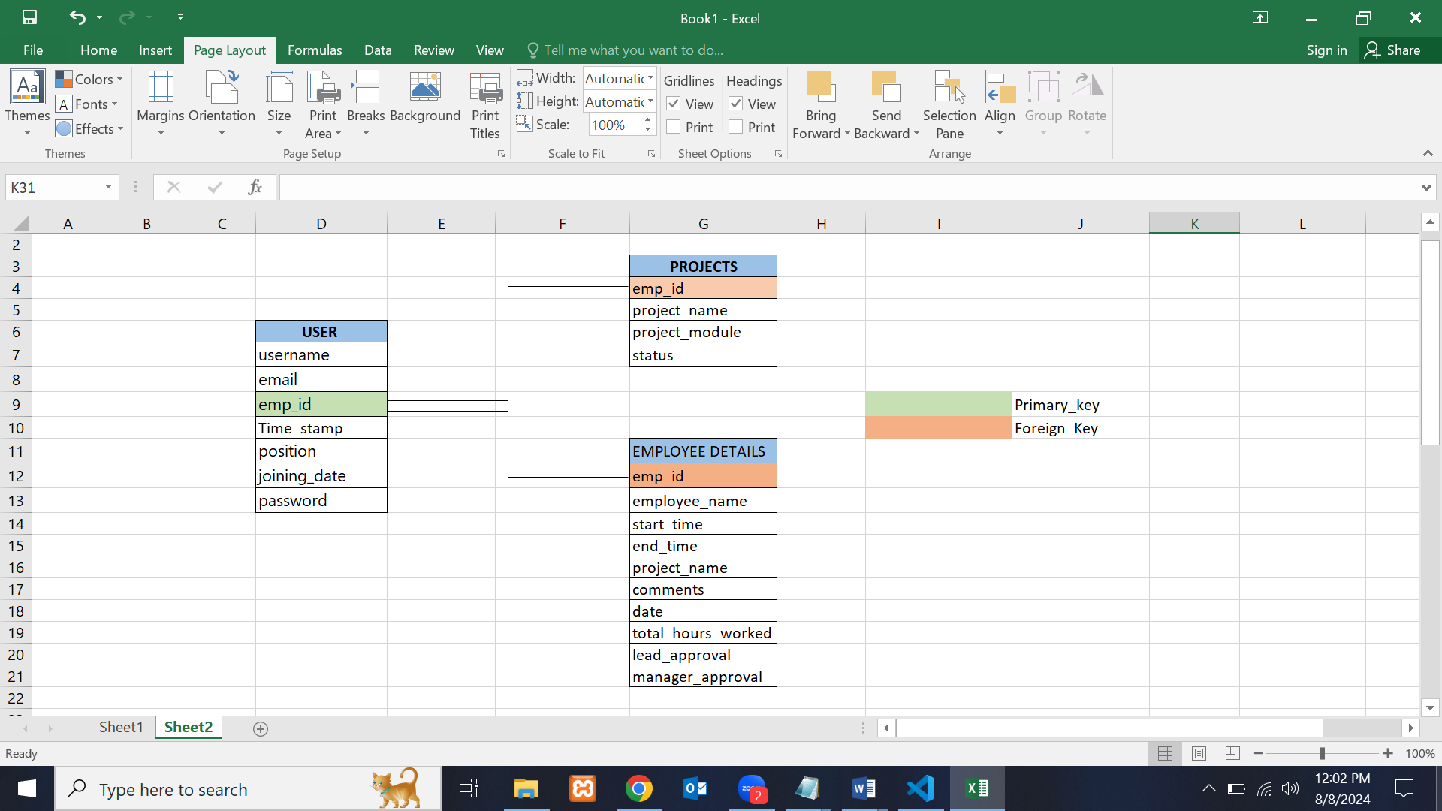

**12.0 Use Case Diagram**

**Employee**

**Admin**

**Lead**

**Manager**

**13.0 Future Enhancements**

**13.1 Send Notifications to Employees**

**Objective:** Implement a notification system to provide feedback and reminders, improving employee engagement and productivity.

**Feedback Notifications:**

Positive Feedback:

Messages: Send encouraging messages such as “You are doing well” based on

performance metrics or timely submissions.

Implementation: Integrate a notification system that triggers messages based on

predefined criteria.

**Reminder Notifications:**

Project Delays:

Messages: Issue reminders for delayed projects with messages like “You are

progressing slowly; please speed up your work.”

Implementation: Set up notifications for overdue tasks or projects, prompting

employees to take action.

**13.2 User Interface Enhancements:**

**Notification Center:**

Design: Add a notification center to the employee dashboard where users can view

received notifications.

Functionality: Allow users to acknowledge or dismiss notifications

**13.3 Enhance Output Reporting**

**Objective:** Improve reporting capabilities to provide insights into timesheet

approvals and other key metrics.

Report Development:

Timesheet Approval Reports:

**Metrics:**

Number of Timesheets Approved: Track the number of timesheets approved by

leads or managers.

Approval Rates: Report the percentage of timesheets approved versus rejected.

Data Collection: Aggregate approval data from the database and generate reports.

**User Interface Enhancements:**

Reporting Dashboard:

Design: Create a dedicated reporting section in the manager's dashboard for

viewing approval metrics.

Visualizations: Use charts and graphs to present data in an easily understandable

format.

**14.0 Project Workflow**

**Step 1:** Database View for users, employee details and project:

Users table:

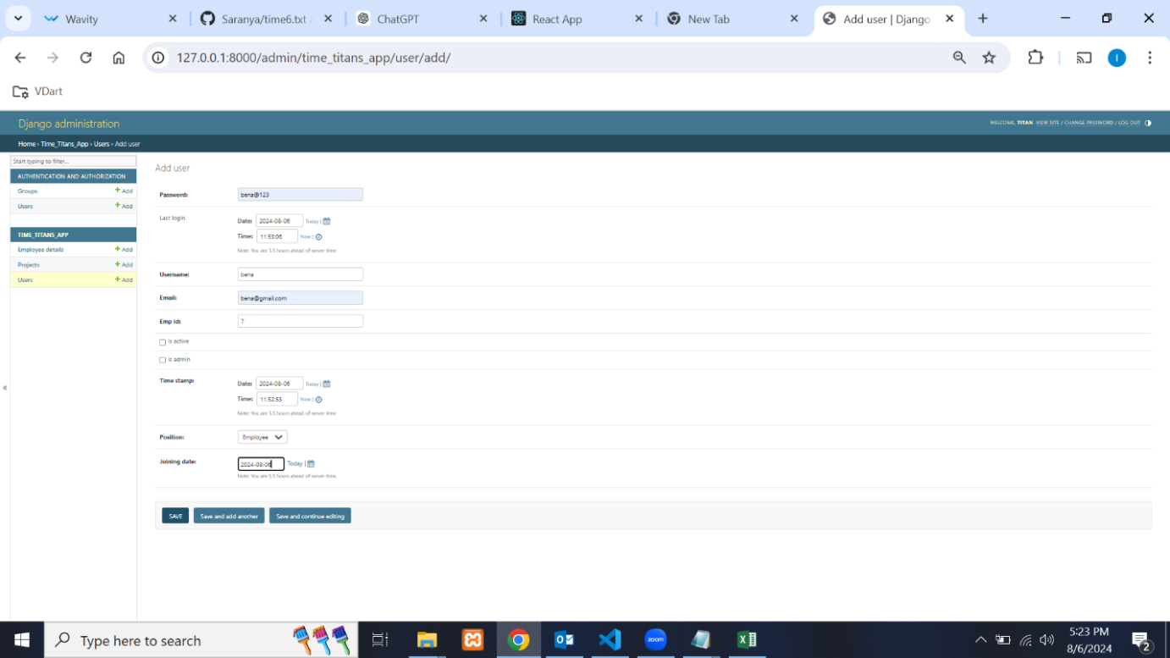

Employee detail table:

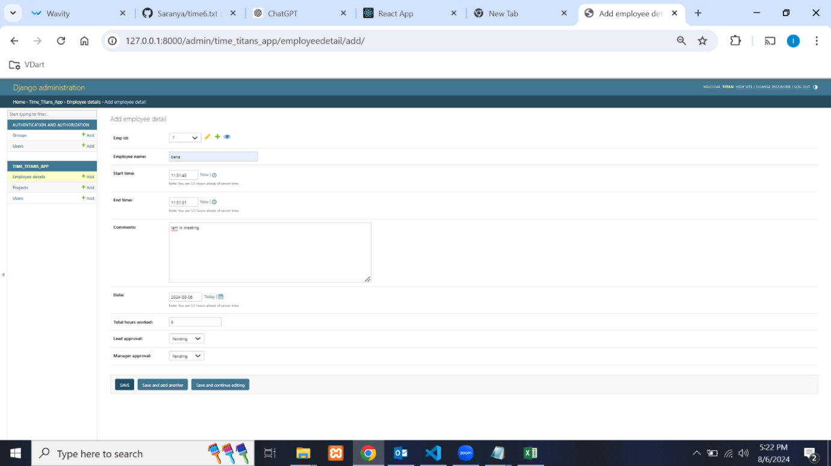

Project table:

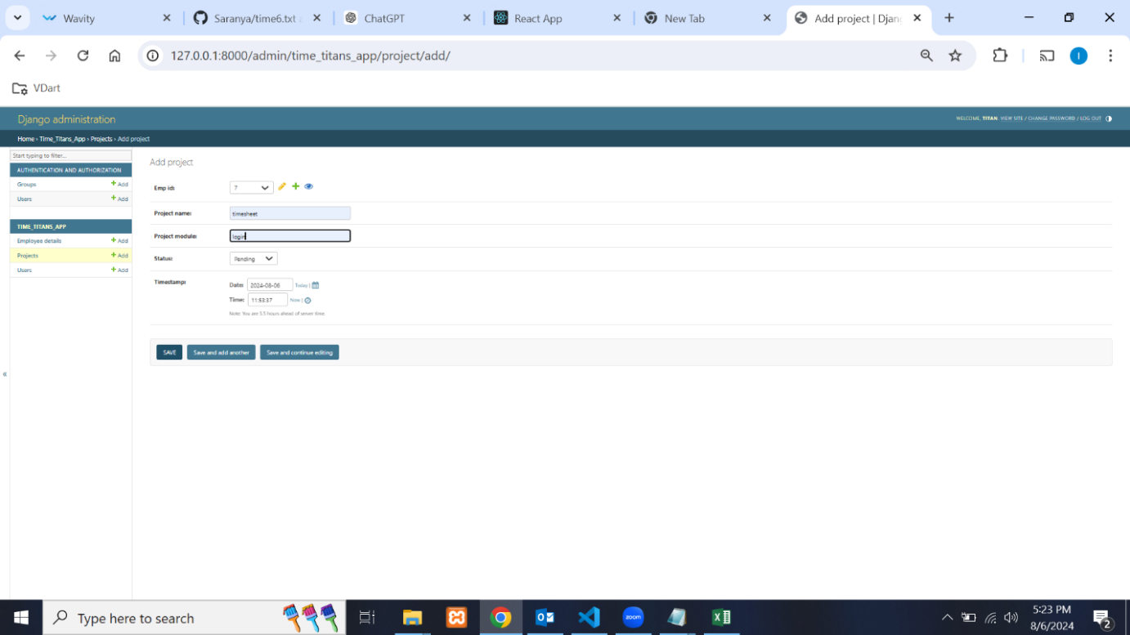

**Step 2:** Login Page view.

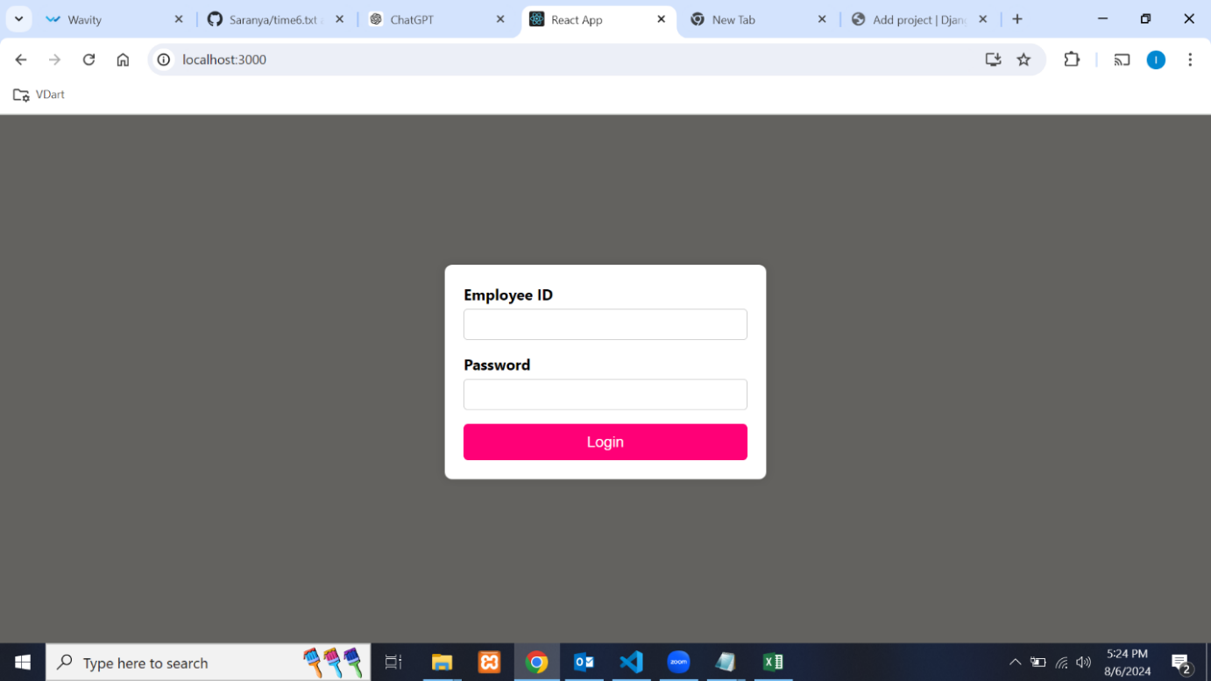

**Step 3:** Employee Login with their specific employee id and go to employee dashboard.

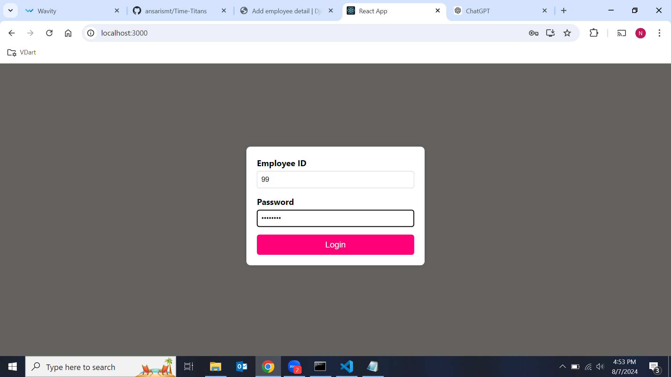

**Step 4:** Total leave days for the particular employee id.

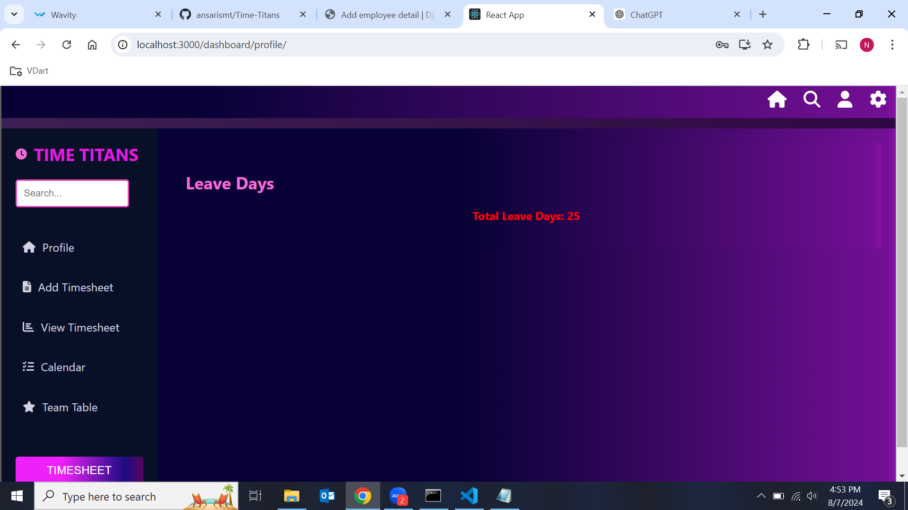

**Step 5:** Update Timesheet, used to update their working hours for the particular employee.

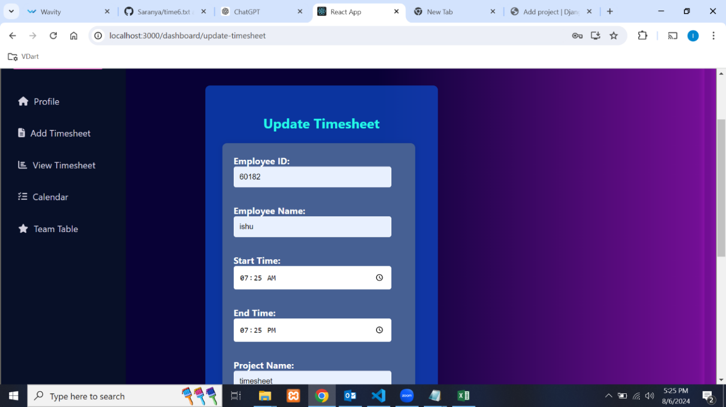

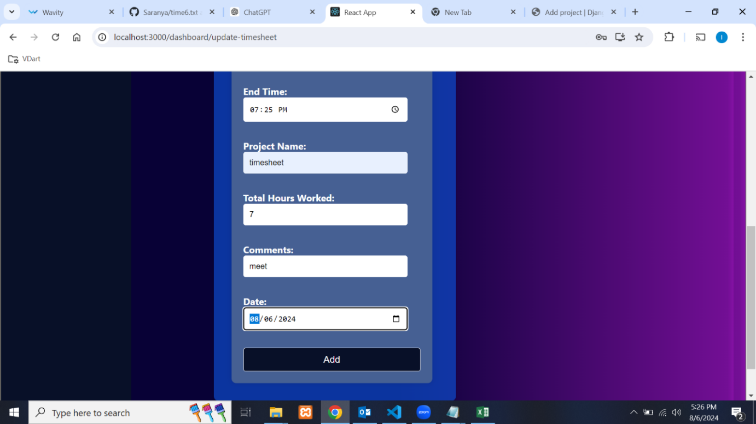

**Step 6:** View Timesheet.

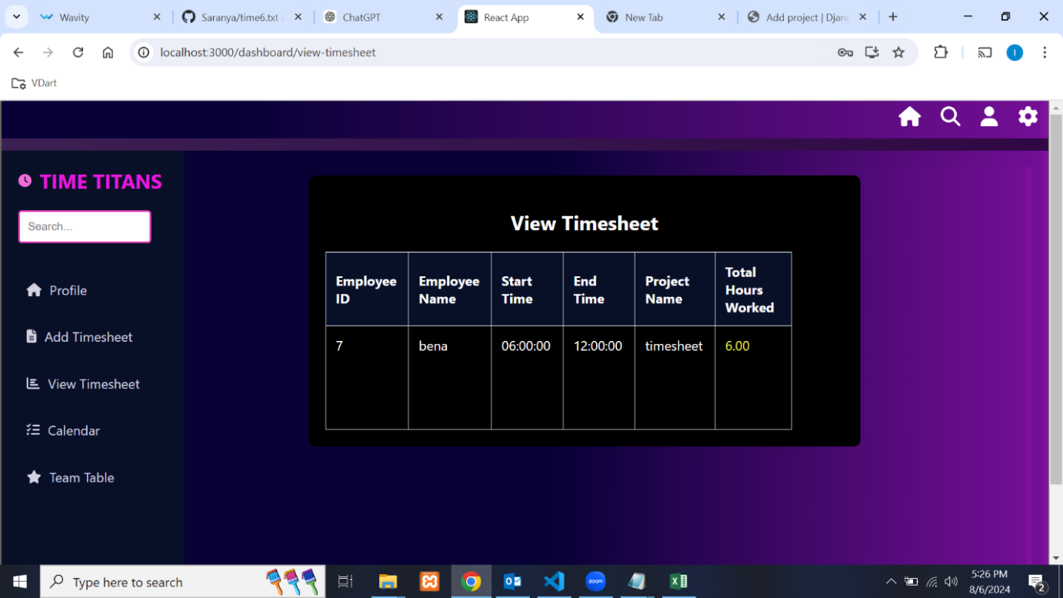

**Step 7:** Calendar view for the particular employee.

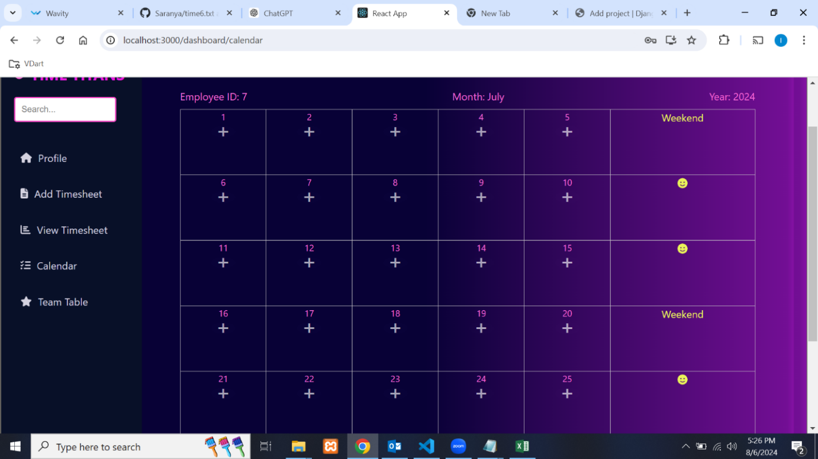

**Step 8:** Team Table, it display the data from the database for the particular employee.

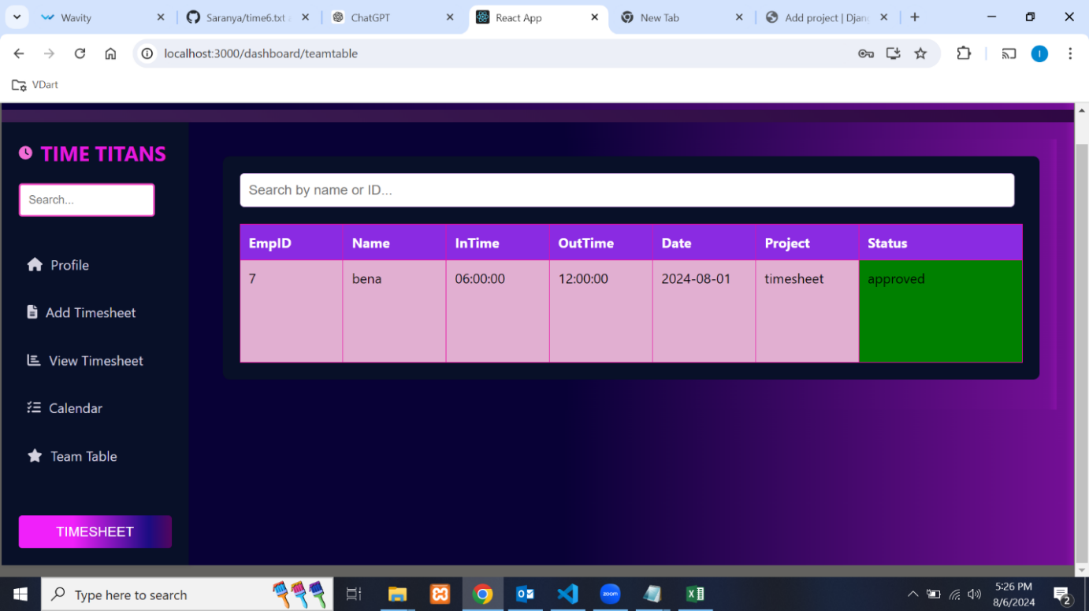

**Step 9:** Lead Login with their specific lead id and go to lead dashboard.

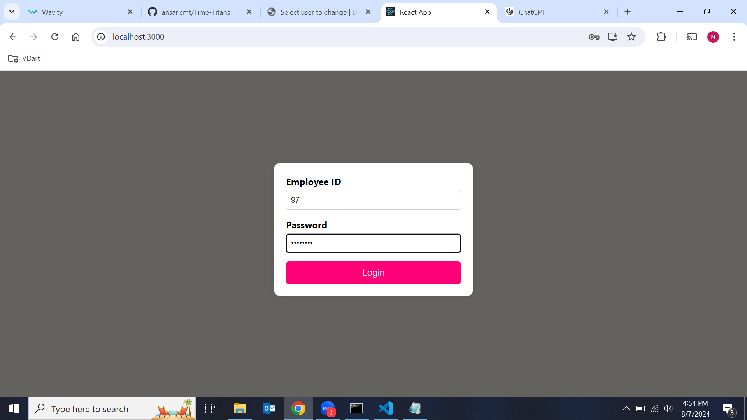

**Step 10:** Total leave days for the particular employee id.

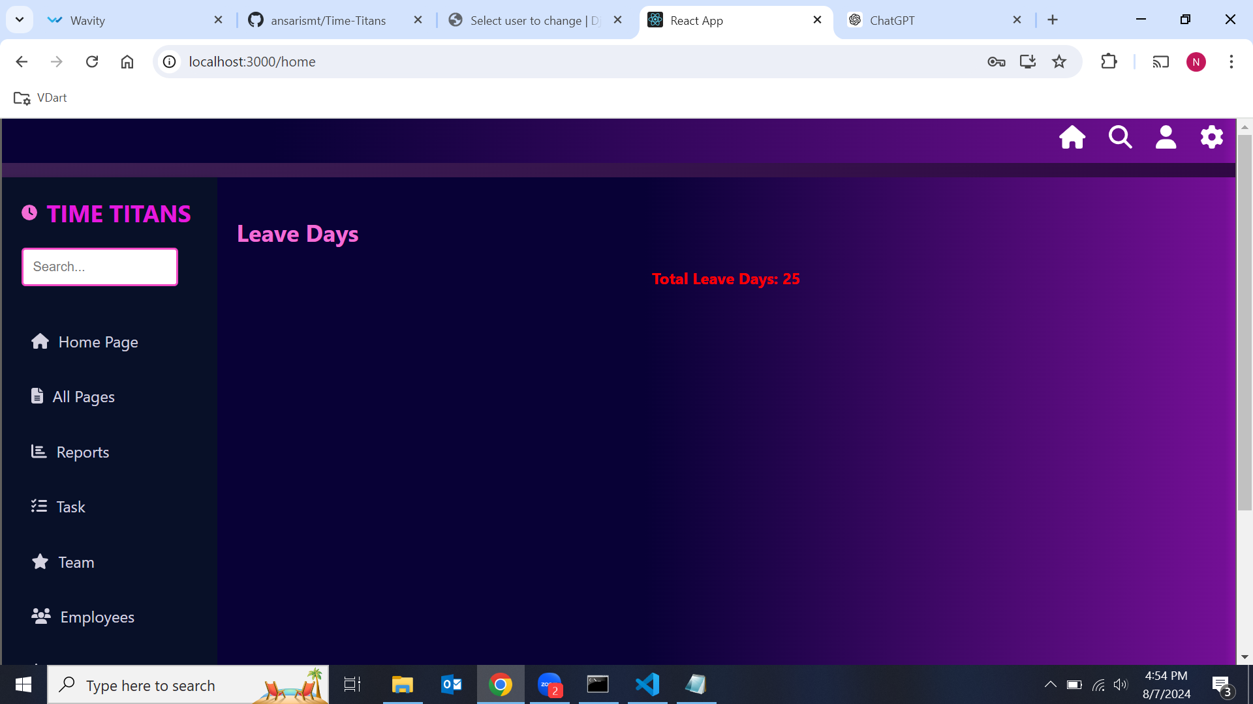

**Step 11:** Task, it show the calendar for the logged in lead.

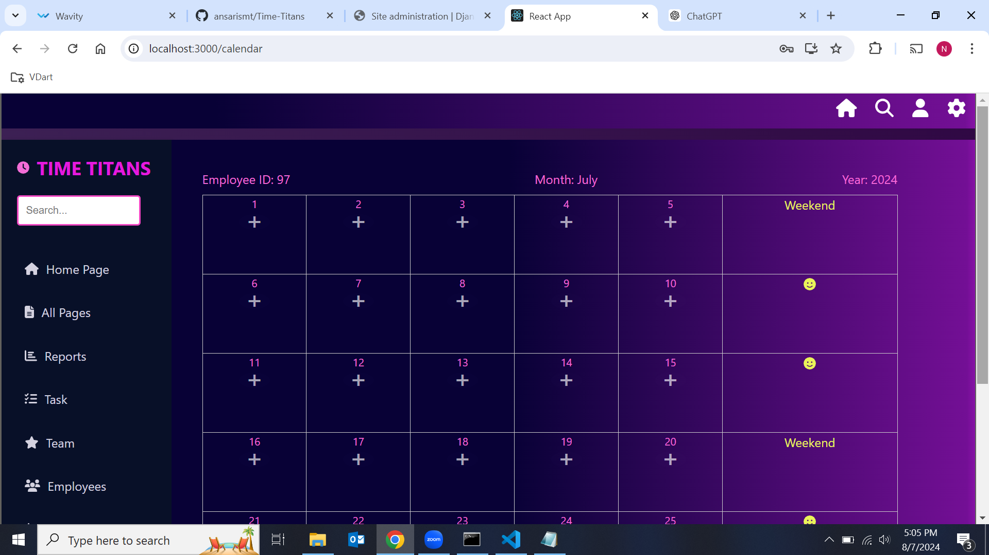

**Step 12:** Employee, It has employee list stored in the database. when we click the employee name it shows lead approve and disapprove button when the lead click the approve or disapprove button, it can be stored in database.

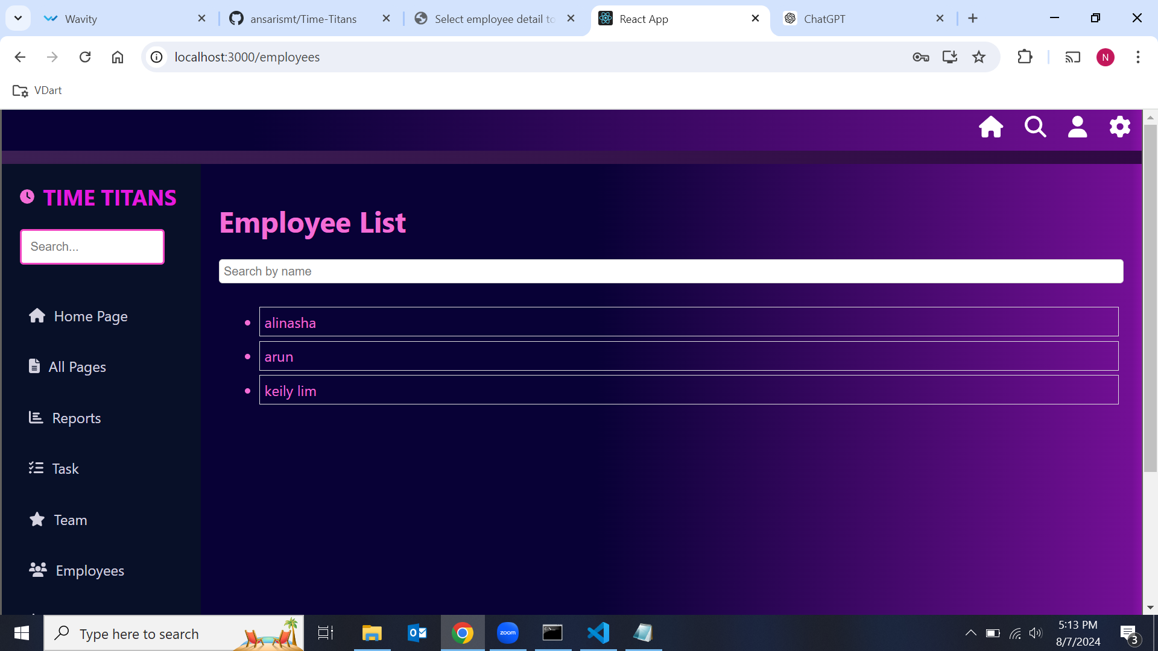

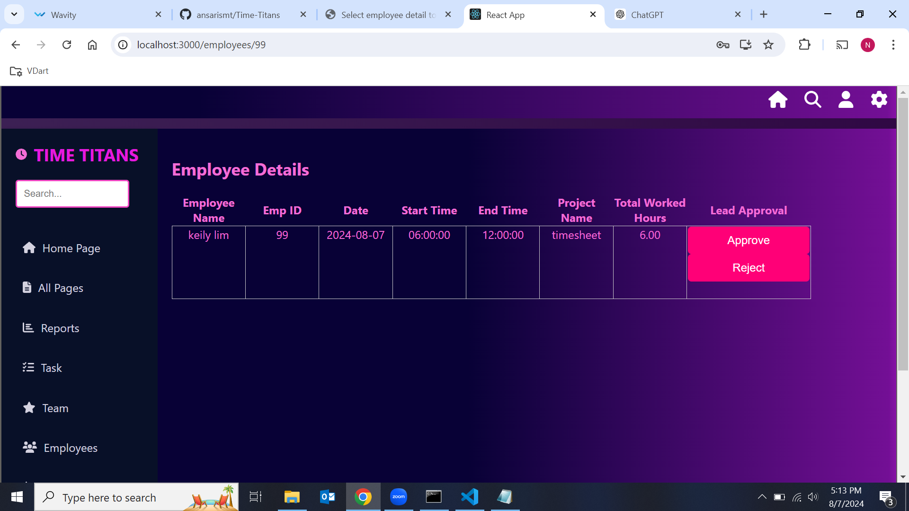

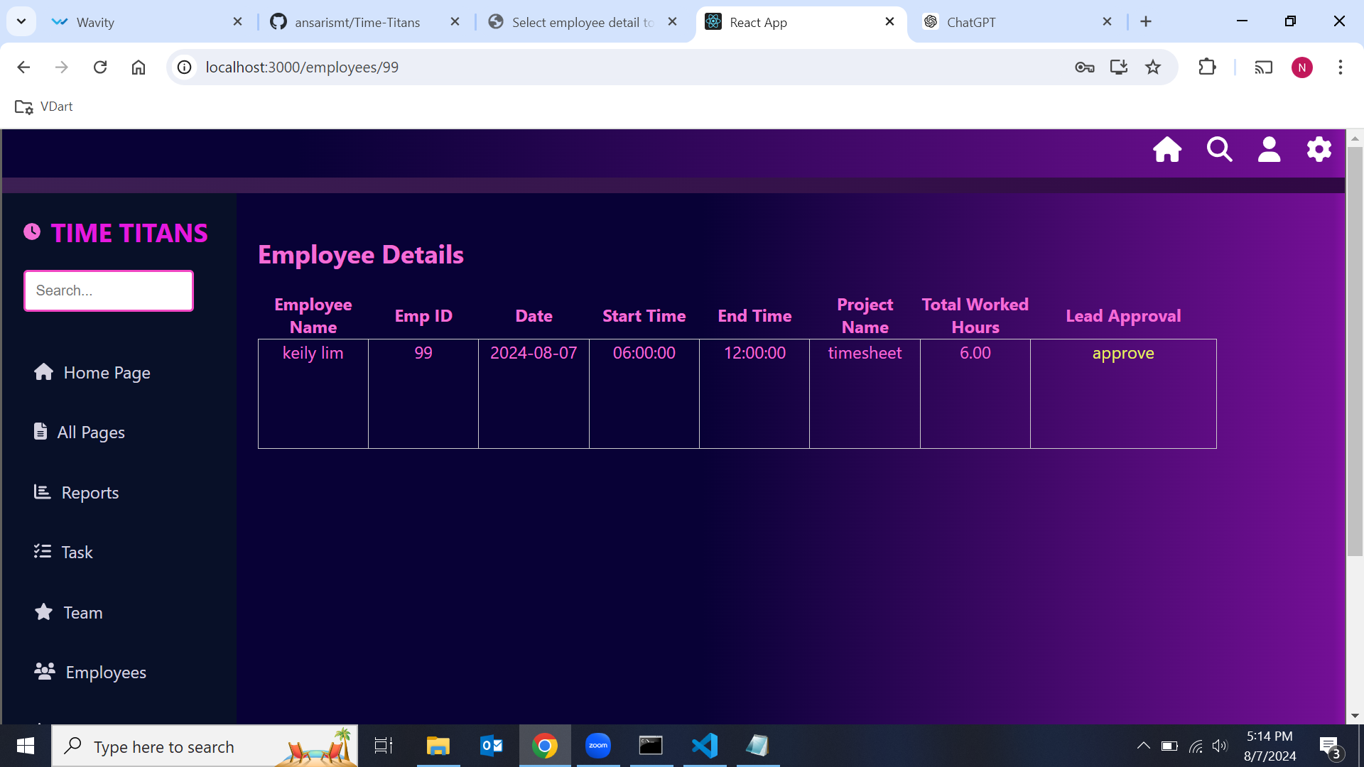

**Step 13:** Team, it display the data stored in the database after the approve or disapprove action status.

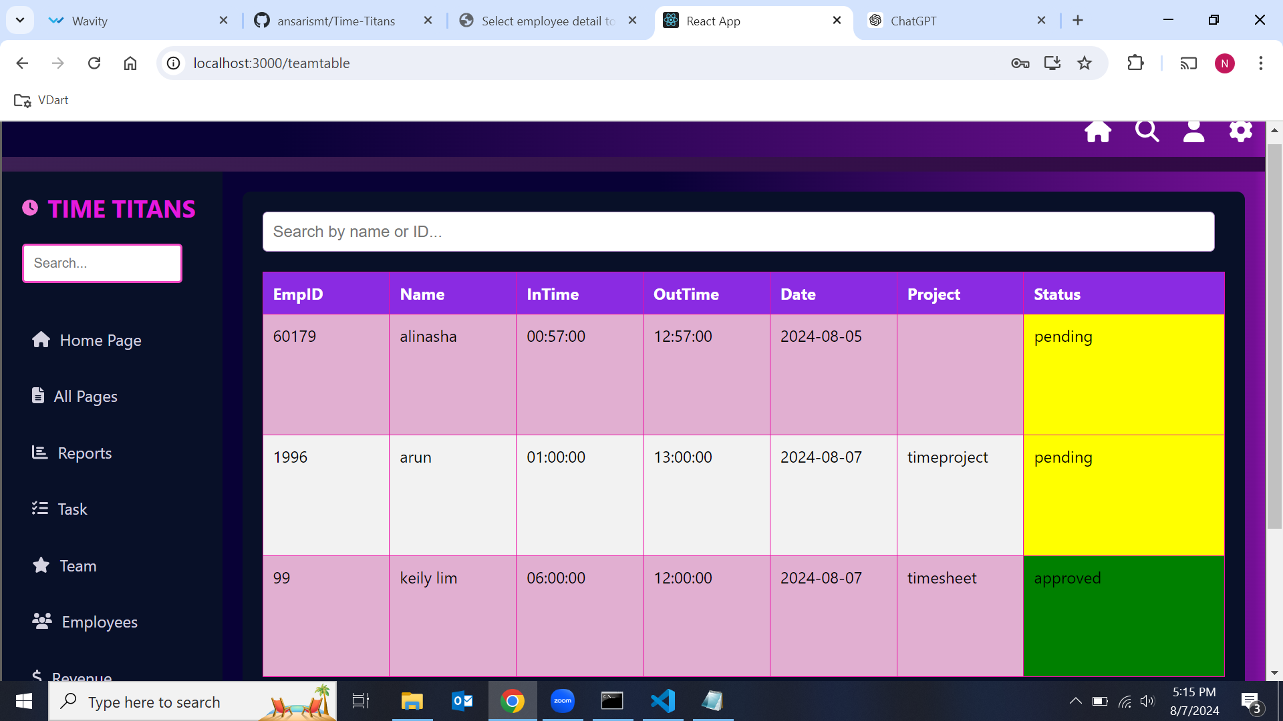

**Step 14:** Manager Login with their specific lead id and go to Manager dashboard.

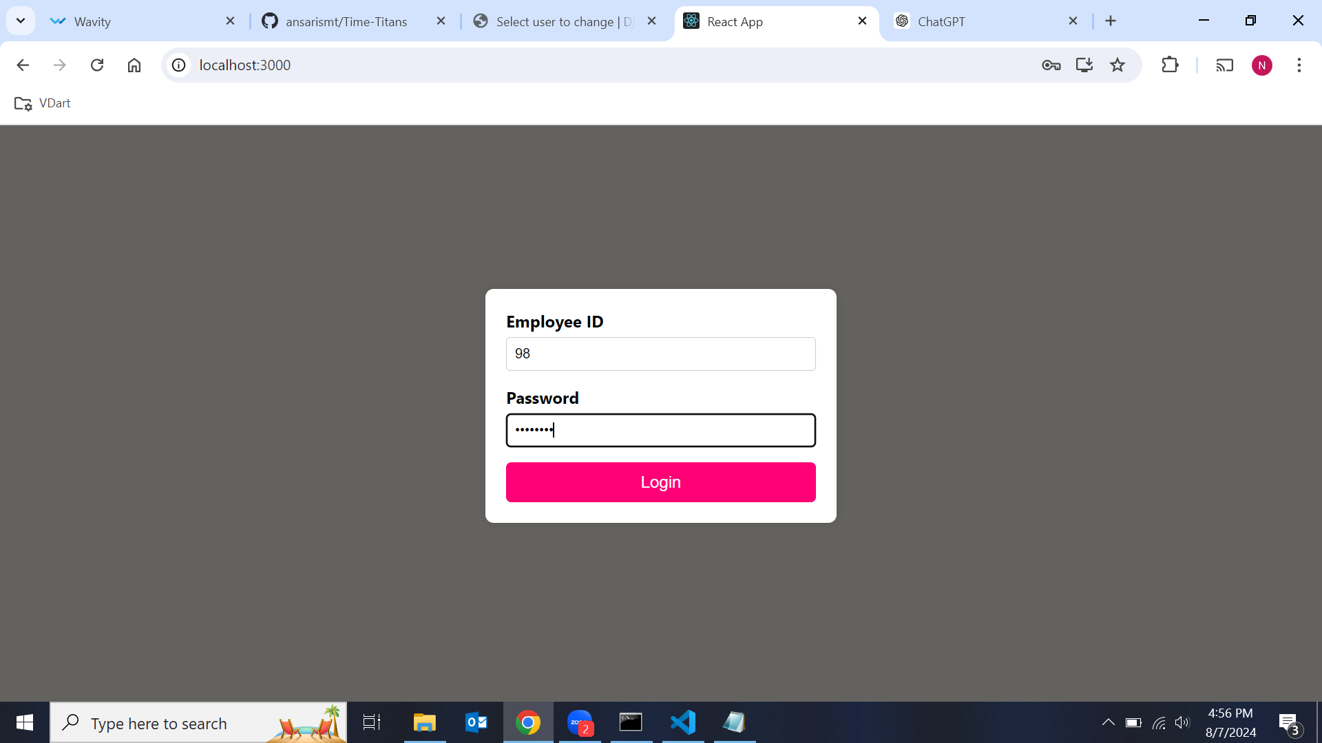

**Step 15:** Total Leave days for particular employee id.

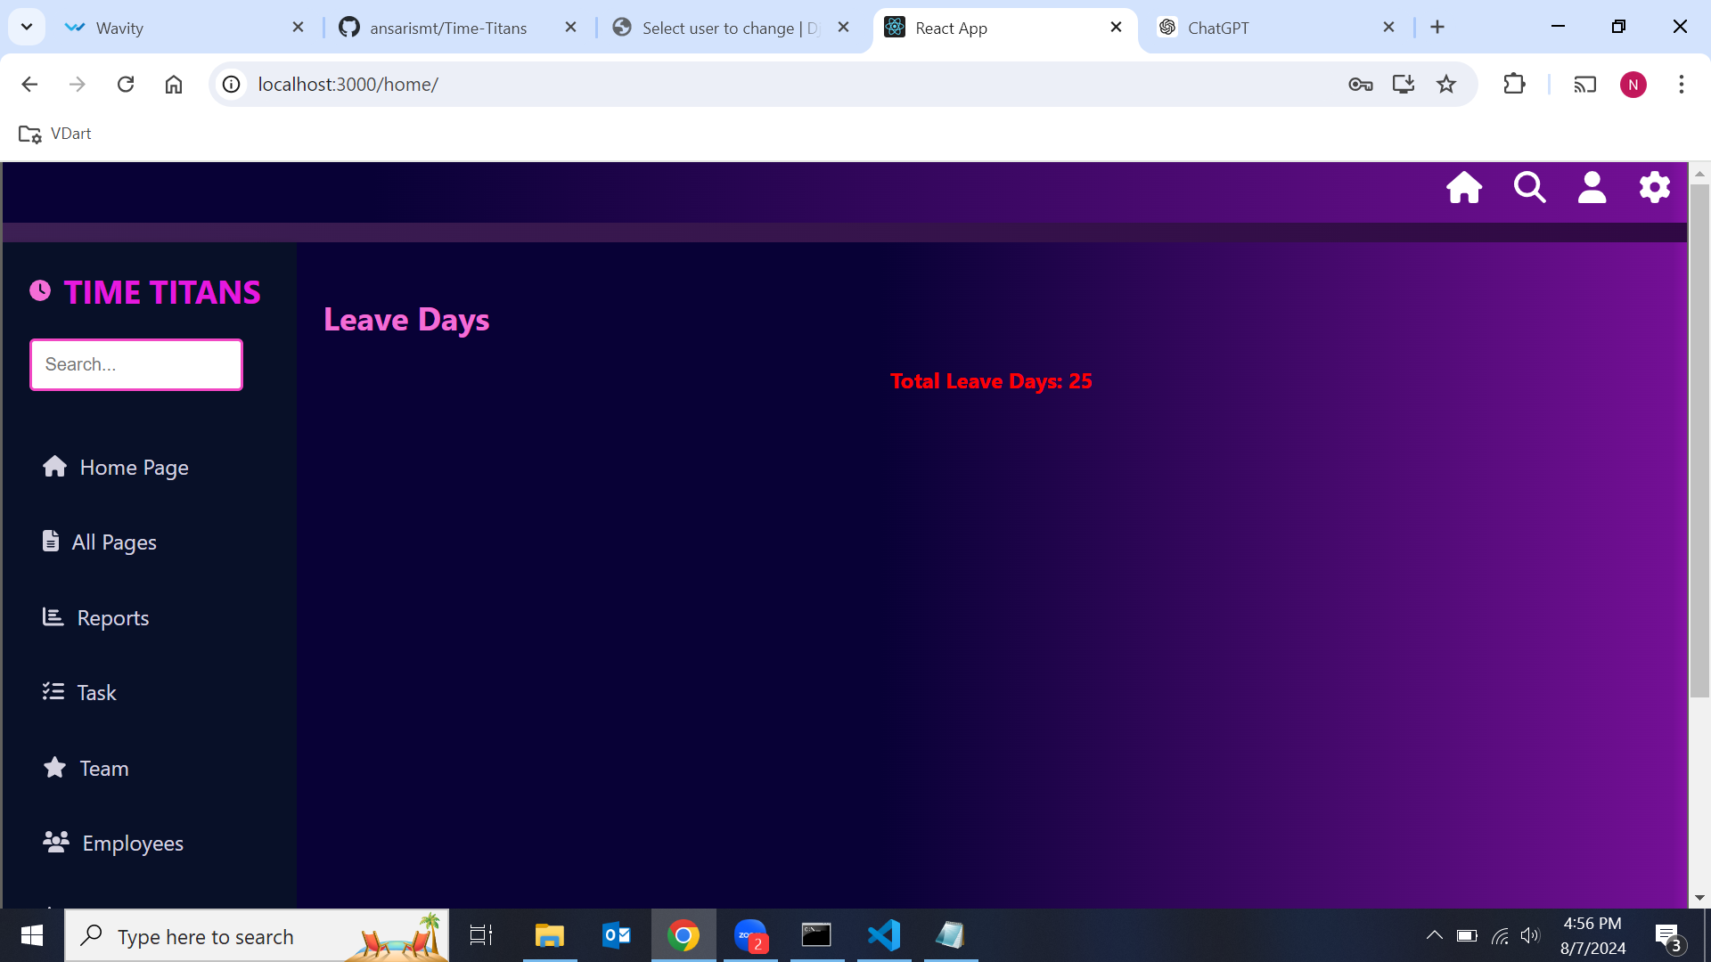

**Step 16:** Employee, It has employee list stored in the database. when we click the employee name it shows Manager approve and disapprove button when the lead click the approve or disapprove button, it can be stored in database. It show the status of the lead.

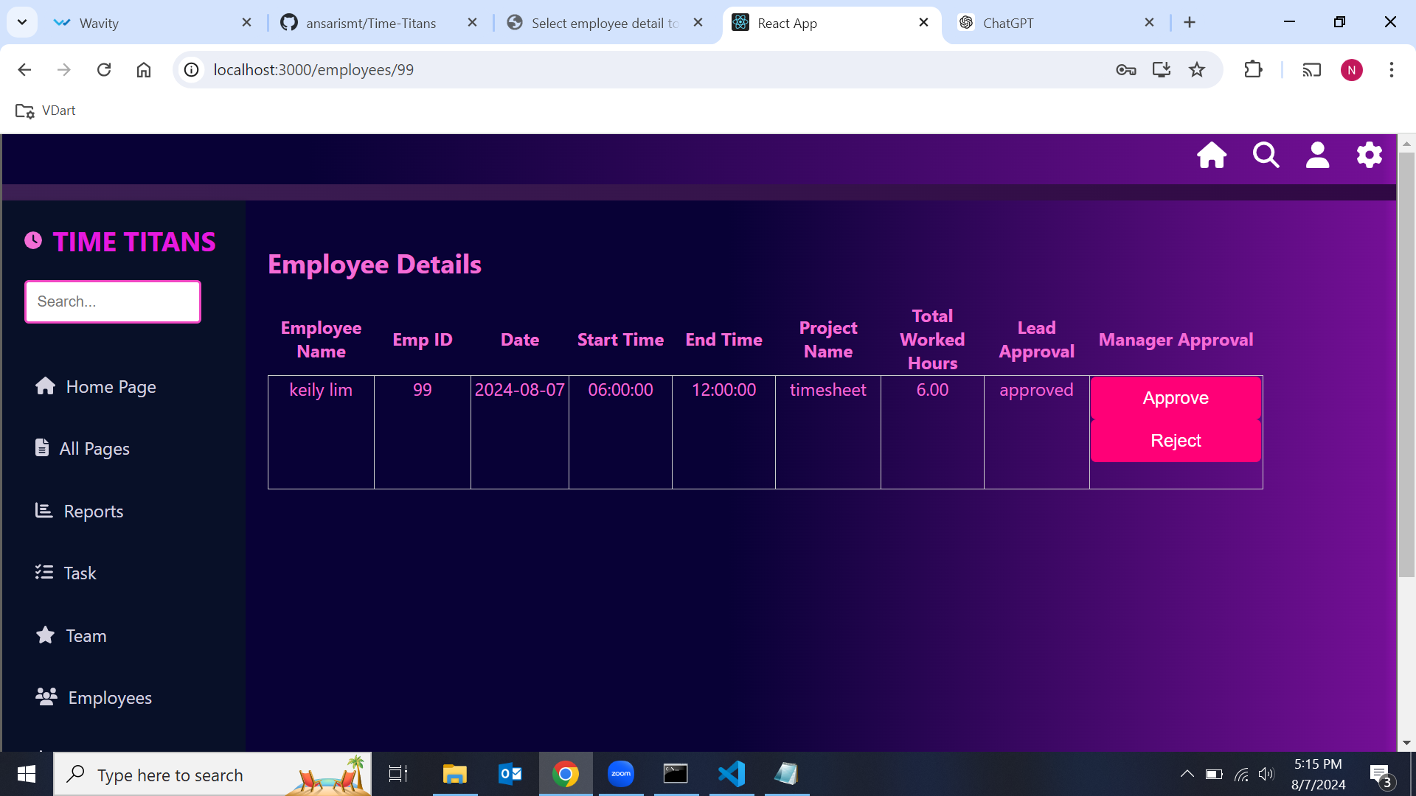

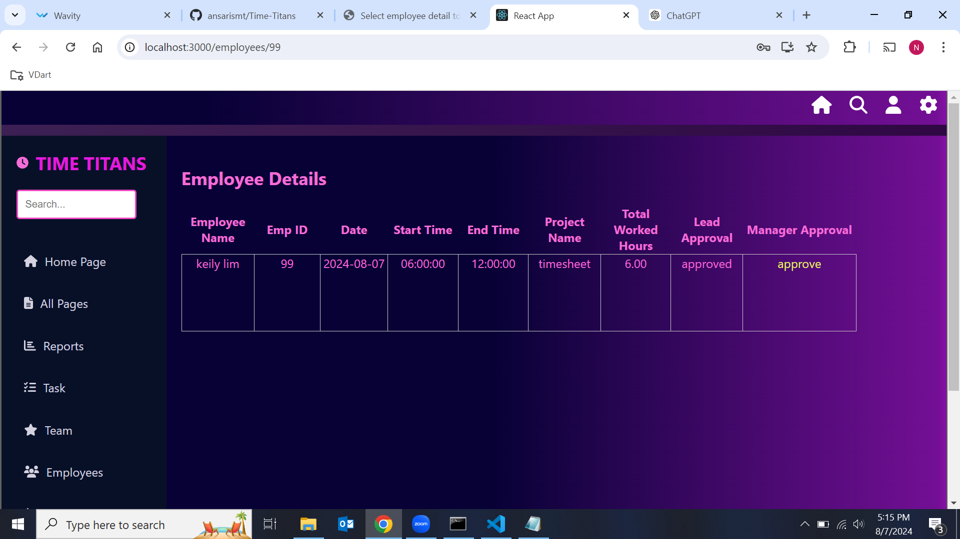

**Step 17:** Task, it show the calendar for the logged in Manager.

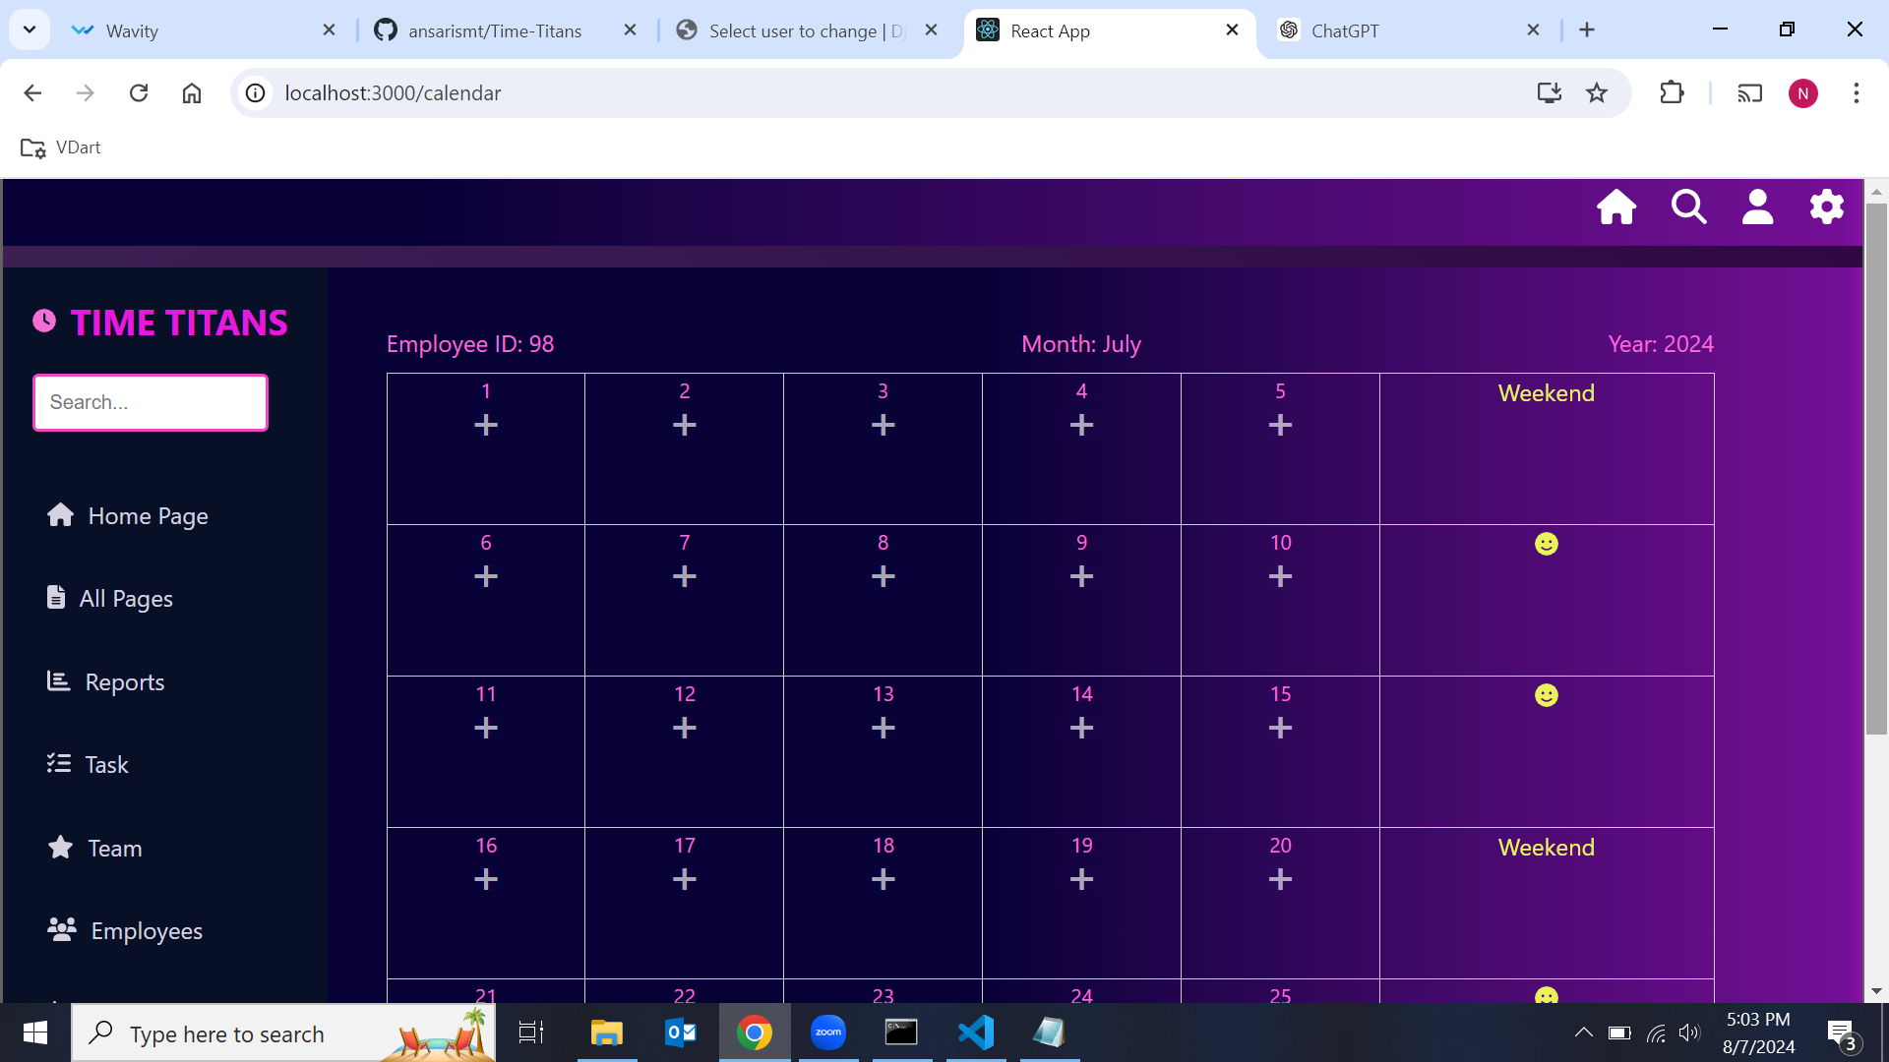

**Step 18:** Team, it display the data stored in the database after the approve or disapprove action Status.



**Conclusion**

The Time Sheet Management project thus aims to streamline the process of tracking and managing employee work hours and project assignments. By providing distinct and tailored dashboards for employees, leads, and managers, the system ensures that all stakeholders have the necessary resources to perform their roles efficiently. Leveraging a well-structured database, the project supports efficient and transparent time management across the organization, ultimately enhancing productivity and accountability.